Data Quality Assessment:
Dataset: NFL Scores and Betting Data (nfl_teams.csv and spreadspoke_scores.csv)
Source: Kaggle.com, compiled from ESPN, NFL.com, Pro-Football-Reference, NOAA, NFLweather.com, and other betting archives.

1. Data Quality Assessment and Improvement
Accuracy:
Data is pulled from reputable sources and cross-referenced (e.g., betting lines from multiple websites; weather from NOAA and NFLweather.com).
Completeness:
The dataset includes NFL scores from 1966 and betting odds since 1979. However, team_division is missing in some nfl_teams.csv rows.
Consistency:
Several fields require standardization:
- schedule_date is a string, not a date.
- schedule_week is 96% numeric, but 4% are labels (e.g., “Superbowl,” “Wildcard”).
- over_under_line includes 0.4% invalid values (e.g., space characters).
- weather_detail contains inconsistent formatting; 0.8% use pipe delimiters (e.g., "Rain | Fog").
Timeliness:
Data is updated weekly, with a maximum potential 7-day lag post-game.
Uniqueness:
No duplicate rows were found.
Summary:
The dataset is accurate and timely but has minor completeness gaps and several consistency issues involving date, weather, and number formatting.

Transformations / Cleaning Applied:
- In nfl_teams.csv, missing team division values were labeled “not applicable” for now.
- over_under_line blank spaces were cleaned and converted to numeric.
- weather_detail was split by delimiter into separate boolean columns (e.g., Rain, Fog).

2. Database Schema Design (SQL DDL)
While all of the completeness issues were resolvable by the actions taken in stage 1, to resolve lingering consistency issues, I designed a star schema during ETL, splitting the data into one fact table (Scores) and three dimension tables: Teams, Stadia, and Weather. See fig 1.
- Teams and Stadia are Type 2 dimensions (include is_current, valid_from, valid_to) to handle changing values.
- Weather is a static reference table, as weather types are fixed. New types may be added, but existing types do not have any variables that might change over time.
Date Handling:
Dates stored as varchar(8) in ISO 112 format to prevent regional conflicts during export (e.g., Excel misreading US/UK date formats). This remediates data consistency issues with the date fields.
Rationale:
This schema improves performance (normalisation, more efficient datatypes), data quality (specifically with regards to consistency, as only one column remains with data consistency issues - schedule_week), and maintainability. SQL DDL was written and tested using MS SQL Server. Field types and definitions documented below, with sample values included.
Further Improvements:
To turn this into a proper ETL pipeline, the views created would populate staging tables and then a merge usp used to check for differences between staging and production tables, updating each where changes are identified and updating iscurrent and validfrom/validto for deprecated rows. This would allow post and pre-match changes to the tables to be reflected accurately.
schedule_week could be spun out into a schedule dimension table where dates have a match_type dimension and the Score fact table could link to it via a 1:1 PK/SK relationship to resolve the last consistency issue.
Screenshots and SQL Samples:
This submission includes before/after dataset screenshots, schema diagrams, and annotated SQL code showing table creation, data types, and field-level assumptions.
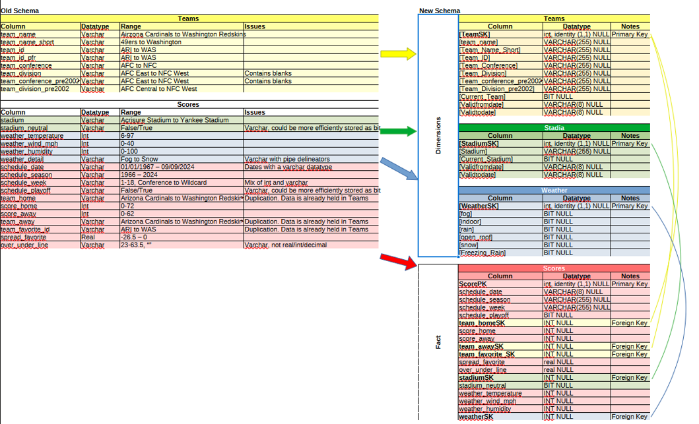Figure 1: Old Schema to New Schema Overview

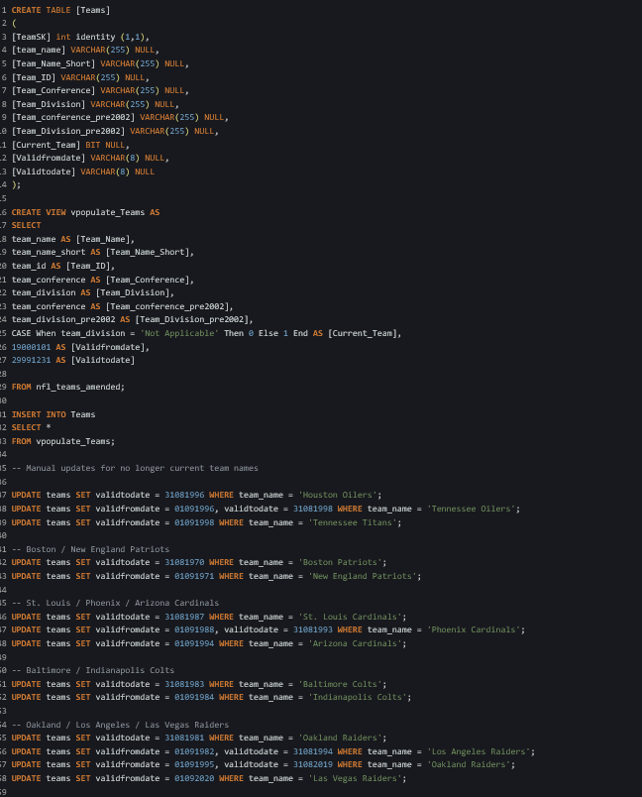Figure 2: Teams Table and View Create and populate code

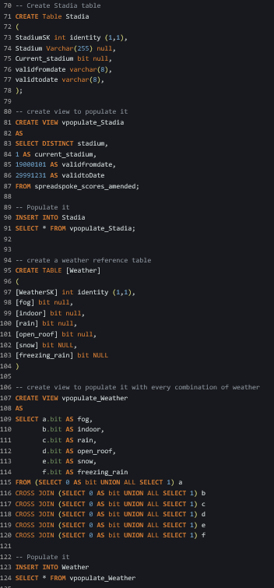Figure 3: Weather and Stadia Table and View SQL commands (including a cartesian join for weather)

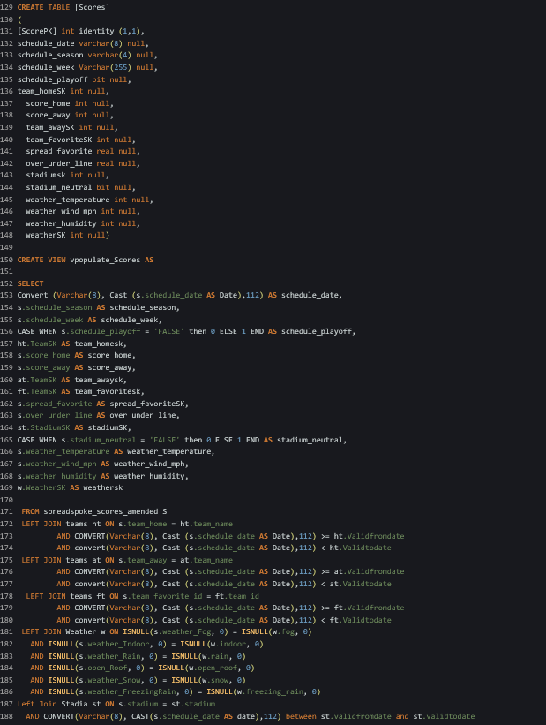Figure 4: Scores Fact Table and View Create
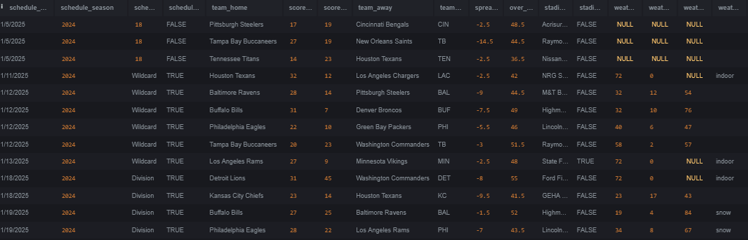Figure 6: Old Scores Table
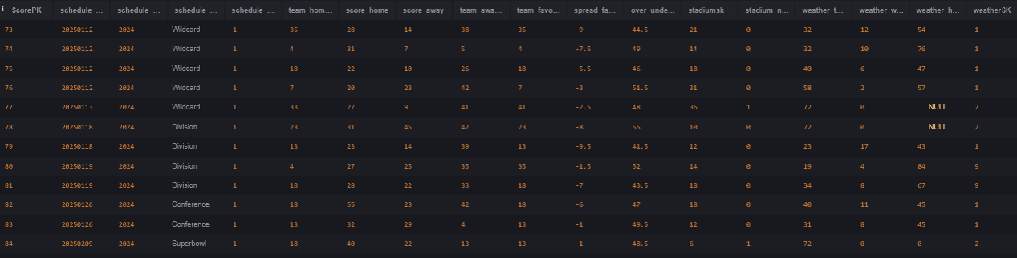Figure 5: New Scores Table

